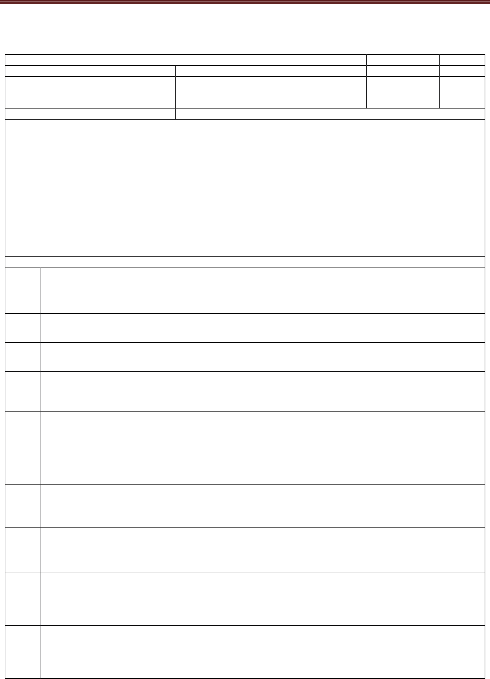
532
SD|35869532
Data Analytics with Excel |  | Semester | 3
Course Code | BCS358A | CIE Marks | 50
Teaching Hours/Week (L:T:P: S) | 0:0:2:0 | SEE Marks | 50
 | 01 | Exam Hours | 100
Examination type (SEE) |  | Practical

Course objectives:

- To Apply analysis techniques to datasets in Excel

- Learn how to use Pivot Tables and Pivot Charts to streamline your workflow in Excel

- Understand and Identify the principles of data analysis

- Become adept at using Excel functions and techniques for analysis

- Build presentation ready dashboards in Excel

Sl.NO Experiments

- Getting Started with Excel: Creation of spread sheets, Insertion of rows and columns, Drag & Fill, use of Aggregate functions.

2
Working with Data : Importing data, Data Entry & Manipulation, Sorting & Filtering.

3
Working with Data: Data Validation, Pivot Tables & Pivot Charts.

- Data Analysis Process: Conditional Formatting, What-If Analysis, Data Tables, Charts & Graphs.

5
Cleaning Data with Text Functions: use of UPPER and LOWER, TRIM function, Concatenate.

- Cleaning Data Containing Date and Time Values: use of DATEVALUE function, DATEADD and DATEDIF, TIMEVALUE functions.

- Conditional Formatting: formatting, parsing, and highlighting data in spreadsheets during data analysis.

- Working with Multiple Sheets: work with multiple sheets within a workbook is crucial for organizing and managing data, perform complex calculations and create comprehensive reports.

- Create worksheet with following fields: Empno, Ename, Basic Pay(BP), Travelling Allowance(TA), Dearness Allowance(DA), House Rent Allowance(HRA), Income Tax(IT), Provident Fund(PF), Net Pay(NP). Use appropriate formulas to calculate the above scenario. Analyse the data using appropriate chart and report the data.

- Create worksheet on Inventory Management: Sheet should contain Product code, Product name, Product type, MRP, Cost after % of discount, Date of purchase. Use appropriate formulas to calculate the above scenario. Analyse the data using appropriate chart and report the data.

lOMoARcPSD|35869532

Data Analytics with Excel: BCS358A Academic Year: 2023-24


- Create worksheet on Sales analysis of Merchandise Store: data consisting of Order ID, Customer ID, Gender, age, date of order, month, online platform, Category of product, size, quantity, amount, shipping city and other details. Use of formula to segregate different categories and perform a comparative study using pivot tables and different sort of charts.

- Generation of report & presentation using Autofilter &macro.

Course outcomes (Course Skill Set):
At the end of the course the student will be able to:

- Use advanced functions and productivity tools to assist in developing worksheets.

- Manipulate data lists using Outline and PivotTables.

- Use Consolidation to summarise and report results from multiple worksheets.

- Apply Macros and Autofilter to solve the given real world scenario.

lOMoARcPSD|35869532

Data Analytics with Excel: BCS358A Academic Year: 2023-24

Assessment Details (both CIE and SEE)

The weightage of Continuous Internal Evaluation (CIE) is 50% and for Semester End Exam (SEE) is 50%. The minimum passing mark for the CIE is 40% of the maximum marks (20 marks out of 50) and for the SEE minimum passing mark is 35% of the maximum marks (18 out of 50 marks). A student shall be deemed to have satisfied the academic requirements and earned the credits allotted to each subject/ course if the student secures a minimum of 40% (40 marks out of 100) in the sum total of the CIE (Continuous Internal Evaluation) and SEE (Semester End Examination) taken together.

Continuous Internal Evaluation (CIE):

CIE marks for the practical course are 50 Marks.

The split-up of CIE marks for record/ journal and test are in the ratio 60:40.

- Each experiment is to be evaluated for conduction with an observation sheet and record write-up. Rubrics for the evaluation of the journal/write-up for hardware/software experiments are designed by the faculty who is handling the laboratory session and are made known to students at the beginning of the practical session.

- Record should contain all the specified experiments in the syllabus and each experiment write-up will be evaluated for 10 marks.

- Total marks scored by the students are scaled down to 30 marks (60% of maximum marks).

- Weightage to be given for neatness and submission of record/write-up on time.

- Department shall conduct a test of 100 marks after the completion of all the experiments listed in the syllabus.

- In a test, test write-up, conduction of experiment, acceptable result, and procedural knowledge will carry a weightage of 60% and the rest 40% for viva-voce.

- The suitable rubrics can be designed to evaluate each student’s performance and learning ability.

- The marks scored shall be scaled down to 20 marks (40% of the maximum marks).

The Sum of scaled-down marks scored in the report write-up/journal and marks of a test is the
CIE marks scored by the student.

Semester End Evaluation (SEE):

- SEE marks for the practical course are 50 Marks.

- SEE shall be conducted jointly by the two examiners of the same institute, examiners are appointed by the Head of the Institute.

- The examination schedule and names of examiners are informed to the university before the conduction of the examination. These practical examinations are to be conducted between the schedule mentioned in the academic calendar of the University.
OMoARcPSD|35869532

Data Analytics with Excel: BCS358A Academic Year: 2023-24
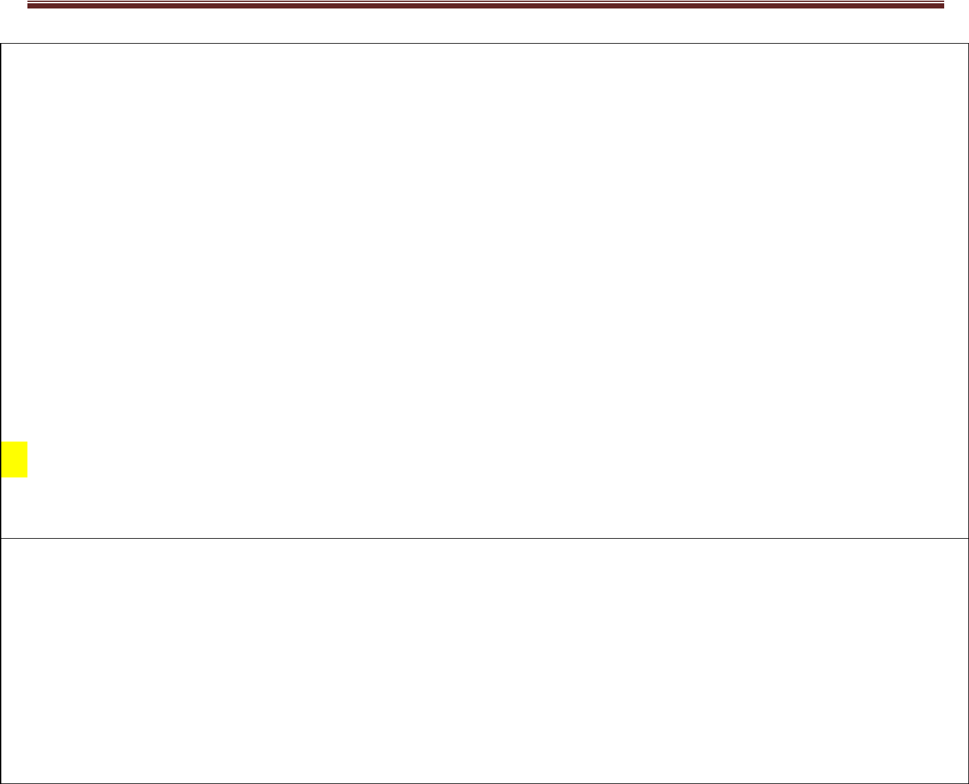

- All laboratory experiments are to be included for practical examination.

- (Rubrics) Breakup of marks and the instructions printed on the cover page of the answer script to be strictly adhered to by the examiners. OR based on the course requirement evaluation rubrics shall be decided jointly by examiners.

- Students can pick one question (experiment) from the questions lot prepared by the examiners jointly.

- Evaluation of test write-up/ conduction procedure and result/viva will be conducted jointly by examiners.

General rubrics suggested for SEE are mentioned here, writeup-20%, Conduction procedure and result in -60%, Viva-voce 20% of maximum marks. SEE for practical shall be evaluated for 100 marks and scored marks shall be scaled down to 50 marks (however, based on course type, rubrics shall be decided by the examiners)

Change of experiment is allowed only once and 15% of Marks allotted to the procedure part are to be made zero.

The minimum duration of SEE is 02 hours
Suggested Learning Resources:
- Berk & Carey - Data Analysis with Microsoft® Excel: Updated for Offi ce 2007®, Third
Edition, © 2010 Brooks/Cole, Cengage Learning, ISBN-13: 978-0-495-39178-4

- Wayne L. Winston - Microsoft Excel 2019: Data Analysis And Business Modeling, PHI,

ISBN: 9789389347180

- Aryan Gupta - Data Analysis in Excel: The Best Guide. (https://www.simplilearn.com/tutorials/excel-tutorial/data-analysis-excel)

lOMoARcPSD|35869532

Data Analytics with Excel: BCS358A Academic Year: 2023-24

An Introduction to MS Excel

What is Microsoft Excel?

Microsoft Excel is a spreadsheet program used to record and analyze numerical and statistical data. Microsoft Excel provides multiple features to perform various operations like calculations, pivot tables, graph tools, macro programming, etc. It is compatible with multiple OS like Windows, macOS, Android and iOS.

A Excel spreadsheet can be understood as a collection of columns and rows that form a table. Alphabetical letters are usually assigned to columns, and numbers are usually assigned to rows. The point where a column and a row meet is called a cell. The address of a cell is given by the letter representing the column and the number representing a row.

MS Excel is a spreadsheet program where one can record data in the form of tables. It is easy to analyze data in an Excel spreadsheet. The image given below represents how an Excel spreadsheet looks like:
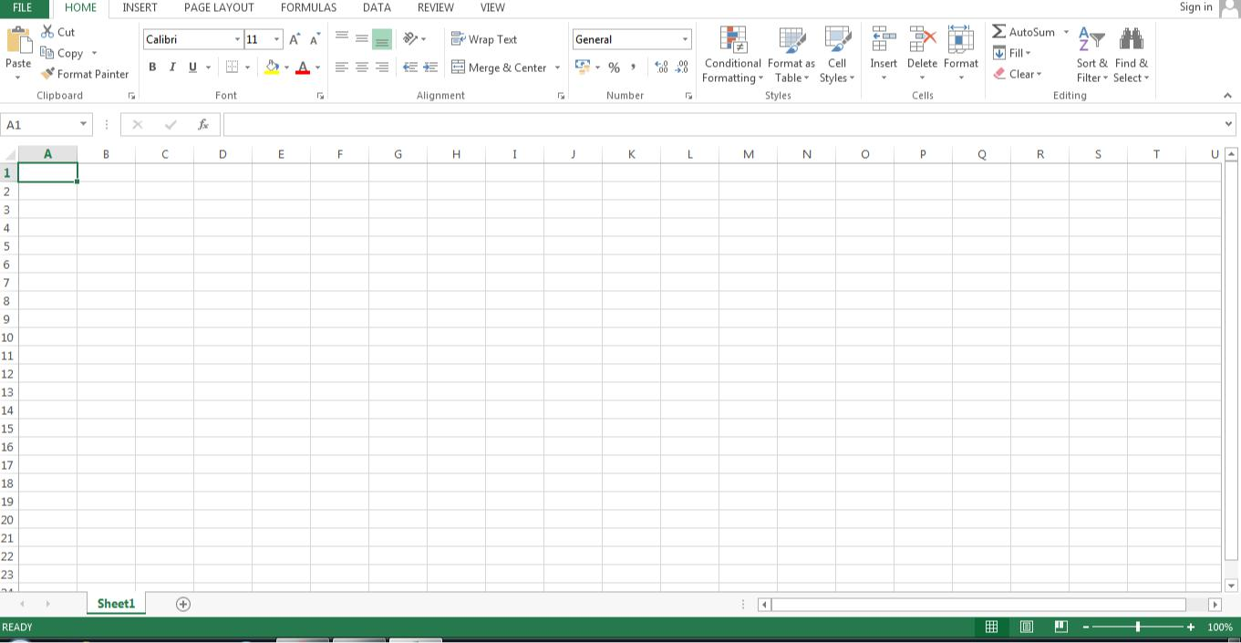

How to open MS Excel?
To open MS Excel on your computer, follow the steps given below:
Click on Start
Then All Programs
Next step is to click on MS Office
Then finally, choose the MS-Excel option
Alternatively, you can also click on the Start button and type MS Excel in the search option available.

lOMoARcPSD|35869532

Data Analytics with Excel: BCS358A Academic Year: 2023-24

What is a cell?

A spreadsheet is in the form of a table comprising rows and columns. The rectangular box at the intersection point between rows and columns forms a cell.

Understanding the worksheet (Rows and Columns, Sheets, Workbooks)

A worksheet is a collection of rows and columns. When a row and a column meet, they form a cell. Cells are used to record data. Each cell is uniquely identified using a cell address. Columns are usually labelled with letters while rows are usually numbers.

A workbook is a collection of worksheets. By default, a workbook has three cells in Excel. You can delete or add more sheets to suit your requirements. By default, the sheets are named Sheet1, Sheet2 and so on and so forth. You can rename the sheet names to more meaningful names i.e. Daily Expenses, Monthly Budget, etc.

Features of MS Excel

Various editing and formatting can be done on an Excel spreadsheet. Discussed below are the various features of MS Excel.
The image below shows the composition of features in MS Excel:
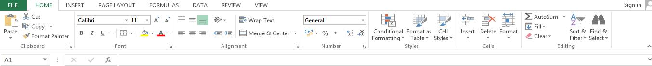

Home

Comprises options like font size, font styles, font colour, background colour, alignment, formatting options and styles, insertion and deletion of cells and editing options.

- Insert

Comprises options like table format and style, inserting images and figures, adding graphs, charts and sparklines, header and footer option, equation and symbols.

- Page Layout
Themes, orientation and page setup options are available under the page layout option.

- Formulas

Since tables with a large amount of data can be created in MS excel, under this feature, you can add formulas to your table and get quicker solutions .

- Data

Adding external data (from the web), filtering options and data tools are available under this category.

- Review

Proofreading can be done for an excel sheet (like spell check) in the review category and a reader can add comments in this part .

- View

Different views in which we want the spreadsheet to be displayed can be edited here. Options to zoom in and out and pane arrangement are available under this category.

lOMoARcPSD|35869532

Data Analytics with Excel: BCS358A Academic Year: 2023-24

Ms-Excel shortcuts:
- Ctrl+N: To open a new workbook.
- Ctrl+O: To open a saved workbook.
- Ctrl+S: To save a workbook.
- Ctrl+C: To copy the selected cells.
- Ctrl+V: To paste the copied cells.
- Ctrl+X: To cut the selected cells.
- Ctrl+W: To close the workbook.
- Delete: To remove all the contents from the cell.
- Ctrl+P: To print the workbook.
- Ctrl+Z: To undo.

Benefits of Using MS Excel

MS Excel is widely used for various purposes because the data is easy to save, and information can be added and removed without any discomfort and less hard work.

Given below are a few important benefits of using MS Excel:

Easy To Store Data: Since there is no limit to the amount of information that can be saved in a spreadsheet, MS Excel is widely used to save data or to analyse data. Filtering information in Excel is easy and convenient.

Easy To Recover Data: If the information is written on a piece of paper, finding it may take longer, however, this is not the case with excel spreadsheets. Finding and recovering data is easy.

Application of Mathematical Formulas: Doing calculations has become easier and less time-taking with the formulas option in MS excel

More Secure: These spreadsheets can be password secured in a laptop or personal computer and the probability of losing them is way lesser in comparison to data written in registers or piece of paper.

Data at One Place: Earlier, data was to be kept in different files and registers when the paperwork was done. Now, this has become convenient as more than one worksheet can be added in a single MS Excel file.

Neater and Clearer Visibility of Information: When the data is saved in the form of a table, analysing becomes easier. Thus, information in a spreadsheet is more readable and understandable.

Applications of MS Excel:

Data Entry and Storage Performing Calculations
Data Analysis and Interpretation Reporting and Visualizations
Accounting and Budgeting
Collection and Verification of Business Data Calendars and Schedules
Administrative and Managerial Duties Forecasting
Automating Repetitive Tasks

lOMoARcPSD|35869532

Data Analytics with Excel: BCS358A Academic Year: 2023-24

Experiment No: 1
Aim:

Getting Started with Excel: Creation of spread sheets, Insertion of rows and columns, Drag & Fill, use of Aggregate functions.

- Create a suitable examination database and find the sum of the marks(total) of each Student ,Average,pass or fail and grade secured by each student.

Rules

Pass if marks in each subject >=35,

Distinction if average>=70,

First class if average>=60 but <70,

Second class if average>=50 but<60,

Third class if average>=35andbut<50,

Fail if marks in any subject is<35.

Display average marks of the class, subject wise and pass percentage Solution:
To find the grade of a student we need to do the following steps

Step1: Typing Student database in Excel2007

Type the student database with the required fields starts fromA1 cell as follows

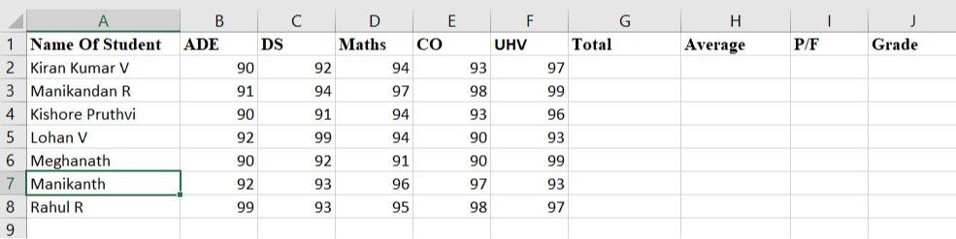

lOMoARcPSD|35869532

Data Analytics with Excel: BCS358A Academic Year: 2023-24

Step2: To find Total Marks of Student

To find the total marks of a student click on the cell“G2” and type the following formula
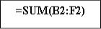

To find the total marks for the remaining students select “G2” cell and drag down to the remaining students.
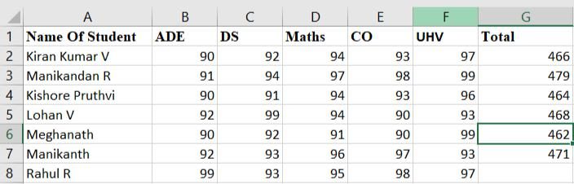

Step 3: To find Average marks

To find the average marks of the student click on the cell“H2”and type the following formula
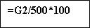

To find the average marks for the remaining students select “H2” cell and drag down to the all the students.

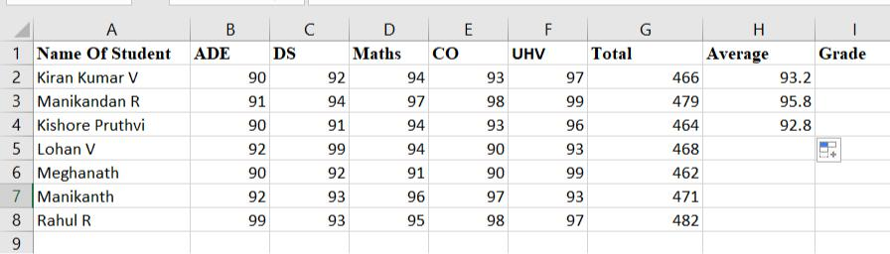

oARcPSD|35869532

Data Analytics with Excel: BCS358A Academic Year: 2023-24

Step4: To Check Pass or Fail

To check whether the student is Pass or Fail select the cell “I2” and type the following formula

To check the remaining students are Pass/Fail select the cell“I2”and drag down to all the students

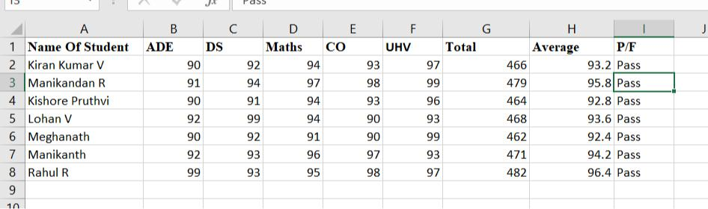

Step5: To find Grade

To find the grade of a student click on the cell “J2” and type the following formula
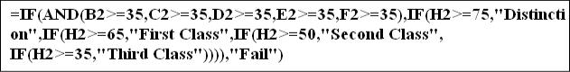

To find the grade for the remaining students select “J2”cell and drag down to the all the students

lOMoARcPSD|35869532

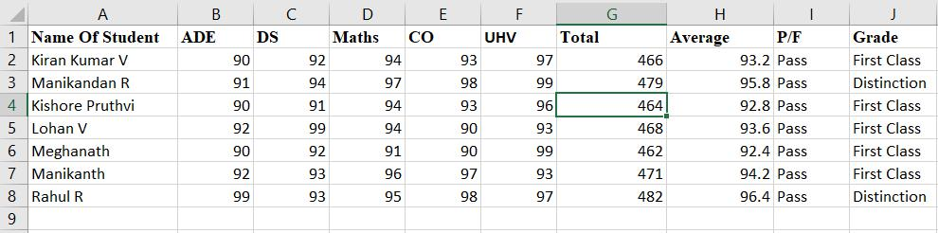

Finally we get the following student database with total, average and grade

Data Analytics with Excel: BCS358A Academic Year: 2023-24

Output:

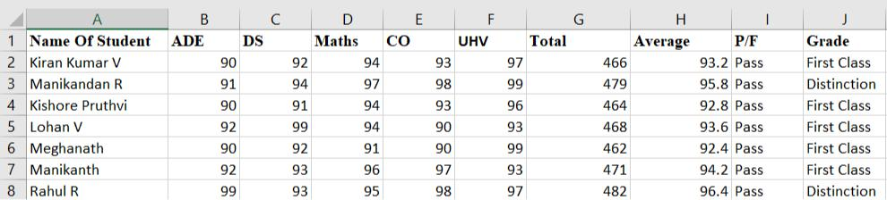

lOMoARcPSD|35869532

Data Analytics with Excel: BCS358A Academic Year: 2023-24

Experiment No: 2
Aim:
Working with Data : Importing data, Data Entry & Manipulation, Sorting & Filtering.

Microsoft Excel is a powerful tool for managing and analyzing data. Whether you are dealing with a large dataset or a simple list, Excel offers various features for importing data, entering information, manipulating content, sorting, and filtering.

Importing Data:

Excel allows you to import data from various sources, making it a versatile tool for handling diverse datasets.

Step 1:Open Excel and Navigate to Data Import

Opening Excel:

Start by launching Microsoft Excel on your computer.

Access Data Import:

Click on the "File" tab in the ribbon at the top of Excel.

Select "Open" from the menu to open a previously saved file.

Alternatively, choose "Get External Data" or "Import" based on your Excel version and select the source of data (e.g., CSV, Database, Web).

Import Data:

If you choose "From Text/CSV," navigate to the location of your CSV file and click "Import."

Excel will guide you through the import process, allowing you to specify delimiters, data types, and other settings.

Data Entry and Manipulation:

Excel provides a user-friendly interface for entering data and performing basic manipulations.

lOMoARcPSD|35869532

Data Analytics with Excel: BCS358A Academic Year: 2023-24

Step 2: Data Entry and Basic Manipulation

Entering Data:

Click on a cell and start typing your data. Press Enter to move to the cell below or use the arrow keys to navigate.

Excel automatically adjusts the width of the cell to fit your data.

Data Manipulation:

Copying and Pasting:

Select a range of cells, right-click, and choose "Copy."

Move to the destination, right-click, and choose "Paste" to copy the data.

Formulae and Functions:

Enter formulas in cells to perform calculations. For example, =SUM(A2:A10) calculates the sum of cells A2 to A10.

Excel offers a wide range of functions (AVERAGE(), IF(), VLOOKUP(), etc.) for advanced calculations.

Data Validation:

Select a range, go to the "Data" tab, and click on "Data Validation."

Set criteria to restrict data entry, such as allowing only numbers between a specific range.

Sorting Data:

lOMoARcPSD|35869532

Data Analytics with Excel: BCS358A Academic Year: 2023-24

Sorting data helps in organizing information in a meaningful way for better analysis.

Step 3: Sorting Data

Sorting Ascending/Descending:

Select the column you want to sort.

Click on the "Data" tab and choose "Sort A to Z" for ascending or "Sort Z to A" for descending order. Alternatively, right-click the selected column and choose "Sort."

Complex Sorting:

For sorting based on multiple criteria (e.g., first sort by Category, then by Price within each Category), use the "Sort" dialog box.

Specify the primary and secondary sort columns along with the sort order for each.

To Sort the Data:

Steps: 1. Select data on list to be sorted.
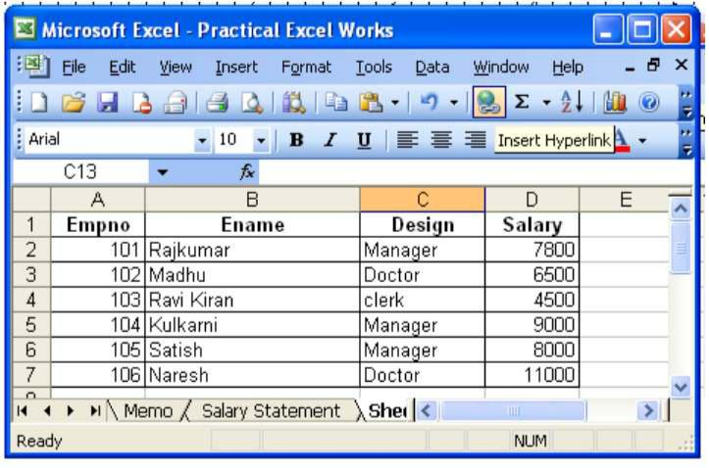

For example salary in the above figure.

- Click the Data Menu and select the sort option. The sort dialog box appears.

lOMoARcPSD|35869532

Data Analytics with Excel: BCS358A Academic Year: 2023-24

3. Select the ascending and descending option in the Sort by section
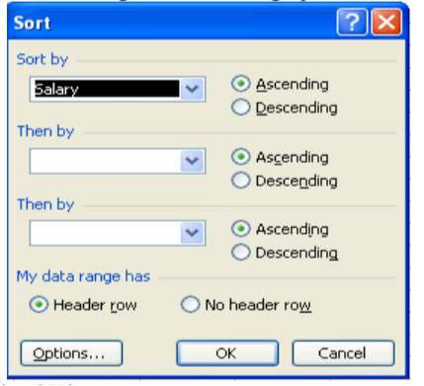

4. Click the OK button

Filtering Data:

Filtering data allows you to focus on specific subsets of information within your dataset.

Step 4: Filtering Data

Applying Filters:

Select your data range.

Click on the "Data" tab and select "Filter."

Dropdown arrows will appear next to each column header.

Click on these arrows to filter data based on specific criteria.

Filtering Criteria:

For text columns, you can filter by specific text values.

For numeric columns, you can filter by numbers greater than, less than, or within a specific range.

For date columns, filter options include dates within a specific period.

- Prepare a salary statement for the following information and plot a graph


SL NO EMP NAME BASIC PAY

Data Analytics with Excel: BCS358A |  | Academic Year: 2023-24
1 | RAMA | 10000
2 | MANJU | 15000
3 | SASH | 11000
4 | HANU | 10000
5 | SITA | 9000


I. Using MS-Excel calculate the following

a. DA is 3% of basic

b. HRA is 5% of basic

c. Tax is 5% of Gross

II. Find maximum and minimum of Basic pay

- Count the number of employees where net salary is more than 10,000 IV. Sort the data on the basis of employee name in ascending order

V. Plot the column graph by taking employee name on x-axis and net salary on y-axis VI. Apply custom filter and display the empnames for whom the Basic pay>=10000

SOLUTION:

- Type the text i.e. “EMPLOYEES SALARY STATEMENT” in the cell from “A1 to H1” using the merge and center button

- Type the SL NO, EMP NAME, BASIC PAY, DA, HRA, GROSS, TAX, NET SALARY in A2, B2, C2, D2, E2, F2, G2, H2 respectively

- Put the data for SL NO, EMP NAME, BASIC PAY

- Calculation for

DA = C3*3%

HRA = C3*5%

GROSS = C3+D3+E3

lOMoARcPSD|35869532

Data Analytics with Excel: BCS358A Academic Year: 2023-24

TAX = F3*5%

NET SLARY = F3-G3

- Calculation for MAXIMUM = max(C3:C8) MINIMUM = min(C3:C8)

COUNT = countif(C3:C8,”&>=10000”)

- For Sort

Select data range -> Click data menu ->Sort -> Sort by -> Emp Name -> Sort on ->

Values -> Order -> A to Z

7. For Graph

Select data range -> Click insert menu -> Chart -> Select column chart -> OK 8. For Filtering

Apply filter selecting Basicpay, then -> click Number filter -> Select greater than and equal to -> enter 10000

Click OK

lOMoARcPSD|35869532

Data Analytics with Excel: BCS358A Academic Year: 2023-24
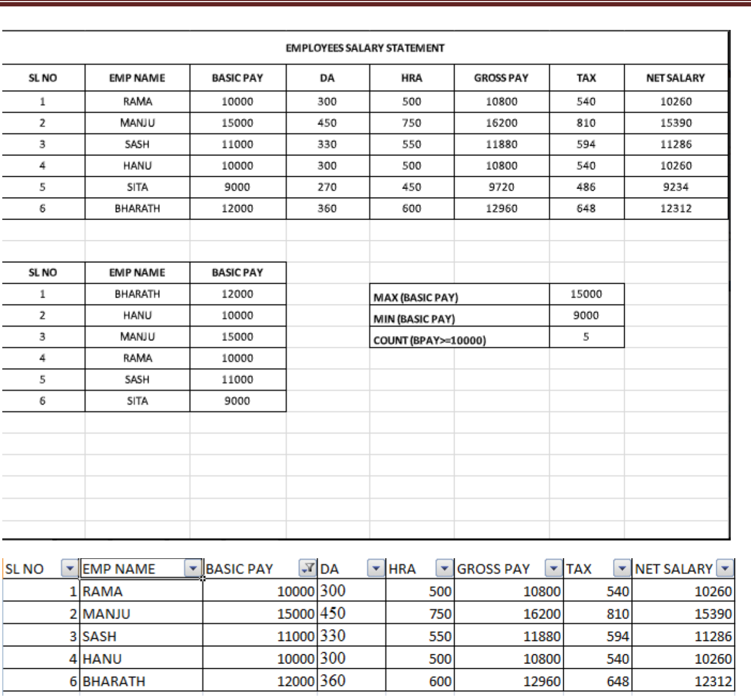

|35869532

